**Case Study: Performance Monitoring and Analysis with JMeter, Prometheus, and Grafana**

**Designing JMeter test plans to simulate realistic user scenarios, including loading the site, searching for products, and other functionality available.**

**Creating Test Plan**

**Adding HTTP Request Defaults**

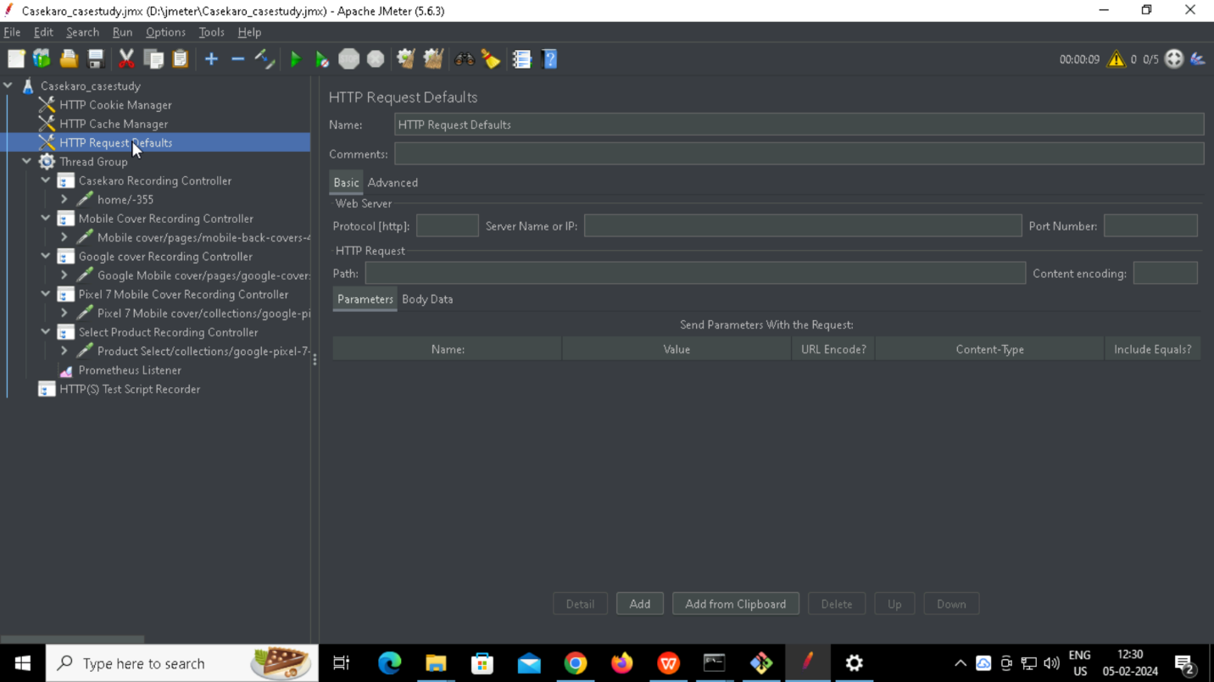

**Adding HTTP Cookie Manager**

**Adding HTTP Cache Manager**

**Creating Thread group**

**Configuring Proxy**

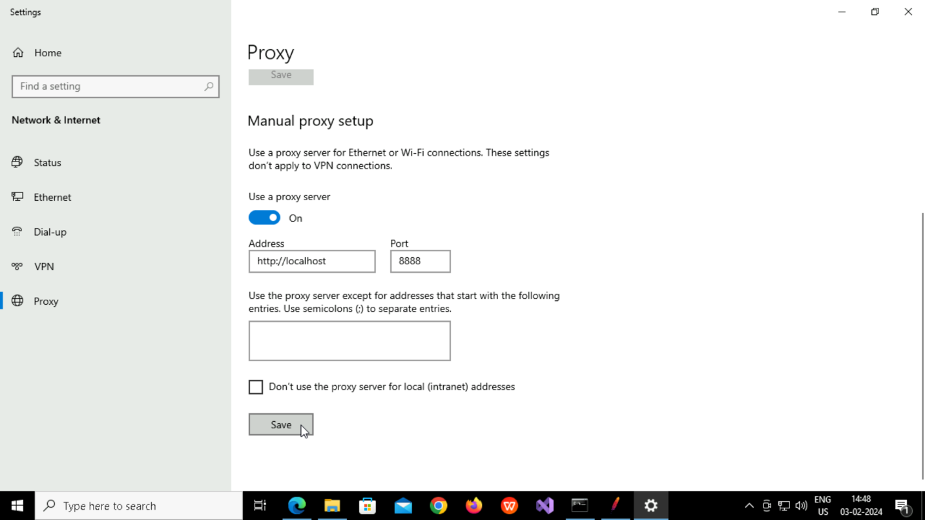

**Managing SSL Certificate**

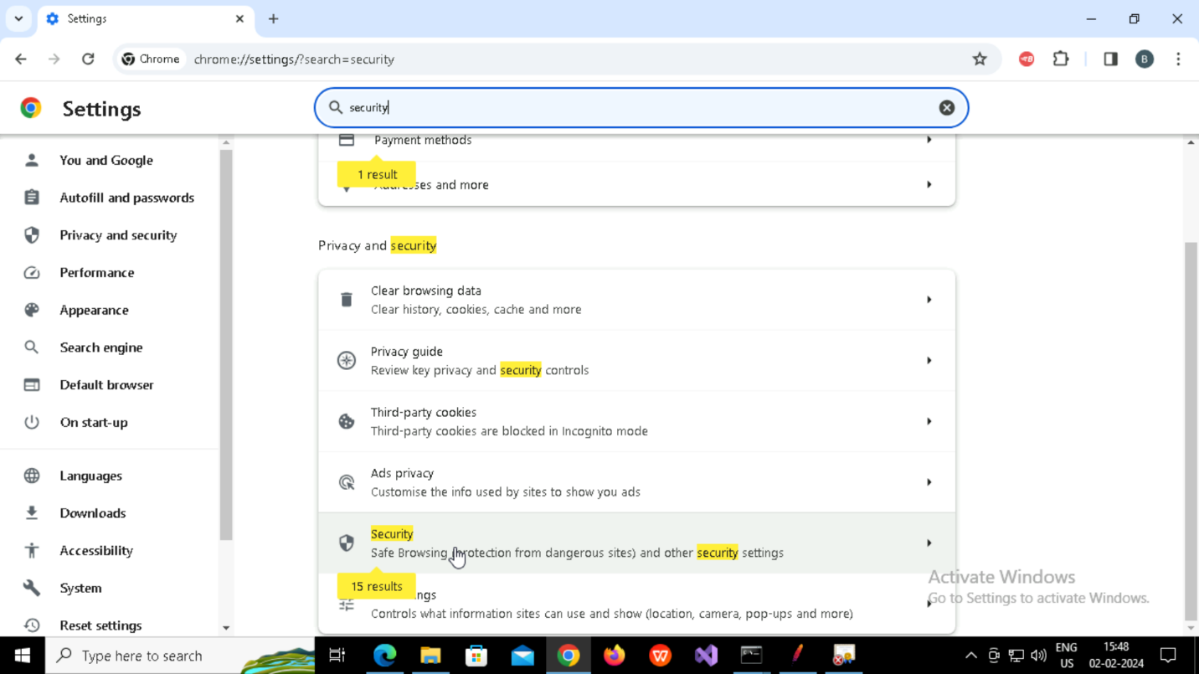

**Adding Recording Controller**

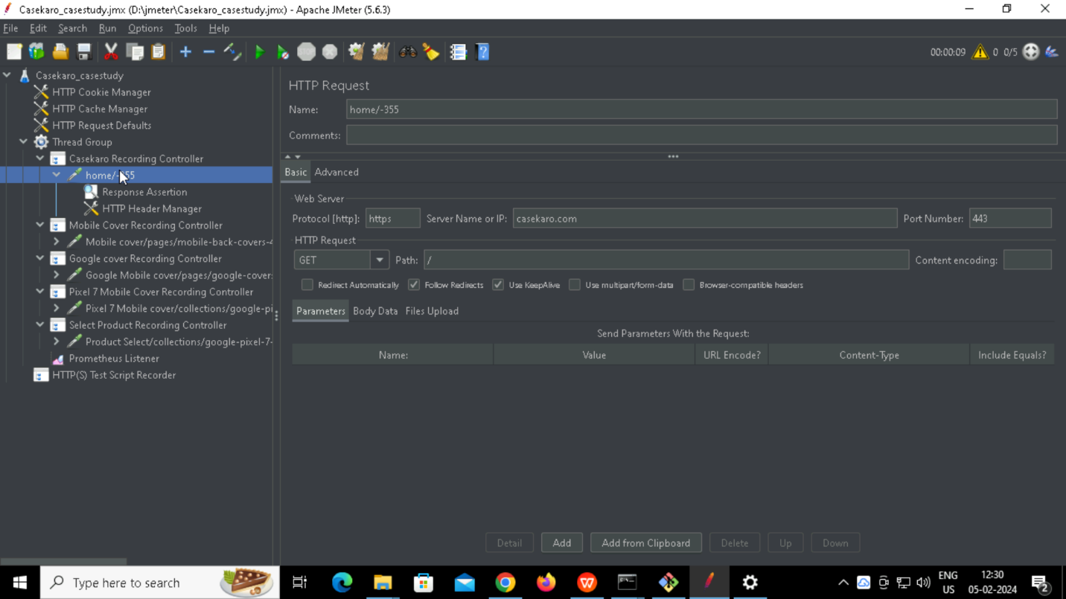

**Adding Test Script Recorder**

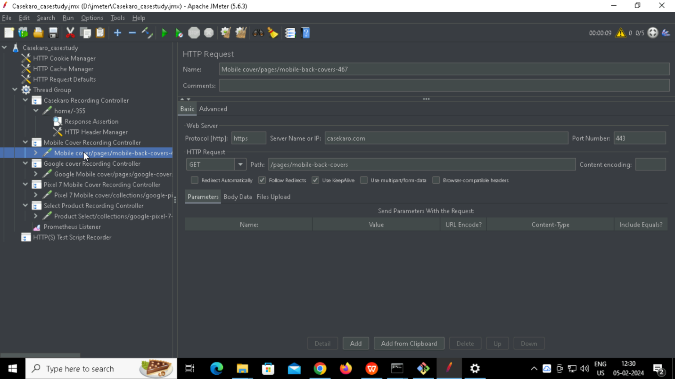

**Adding Prometheus Listener**

**Give the Prometheus port inside Jmeter/bin/user properties file**

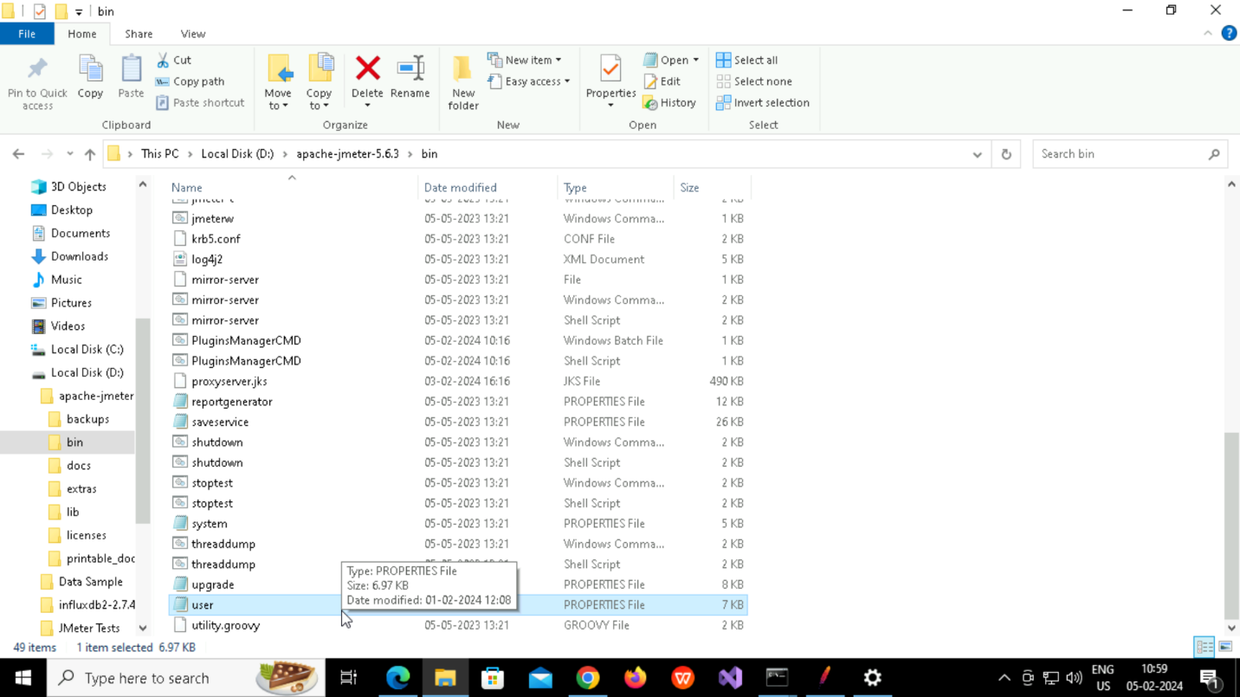

**Add Prometheus port 9270**

**Starting Prometheus**

**Opening Prometheus in browser**

**Checking the rule**

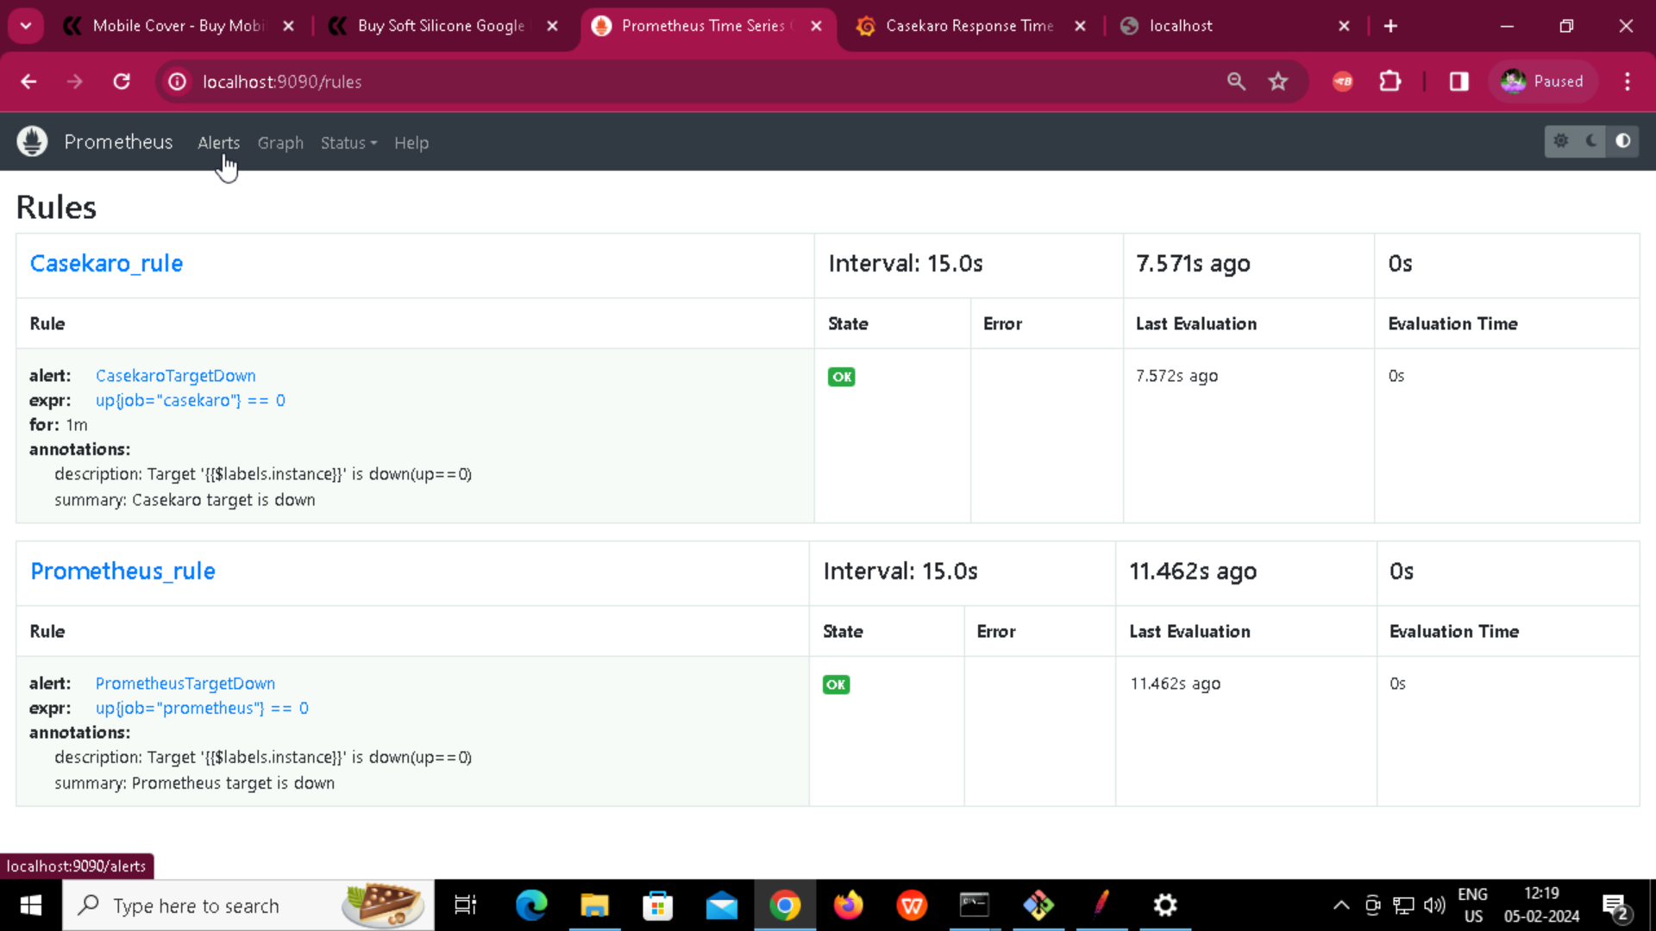

**Checking the alert**

Grafana Dashboard

